# Lab 2: MD5 Collision Lab

## Task 1.1

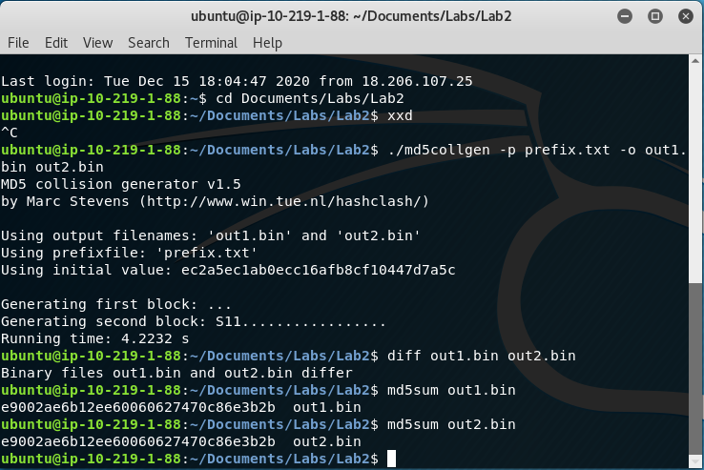

1. If the length of your prefix file is not multiple of 64, what is going to happen to theout1.binfile? Using the hex editor open the fileout1.binand examine the first 64 bytes.
   1. The first 26 bytes are made up of the letters of the alphabet (also the length of the prefix file) and the rest of the 64-byte block is left blank, until the garbled hexadecimal data in the rest of the file
2. Using prefix1.txt with exactly 64 bytes and run the collision tool again naming the output file out1-64.bin and out2-64.bin. What is going to happen to the out1-64.bin file? Using the hex editor open the file out1-64.bin and examine the first 64 bytes.
   1. The first 64 bytes of the new out1-64.bin is all the letters of the alphabet (lowercase), the numbers 1-9 + 0, all the letters (uppercase), an exclamation point, then a new line character. Essentially, all 64 bytes are filled up with data.
3. Are the data (128 bytes) generated by md5collgen completely different for the two output files? Using the hex editor, identify the first four bytes that are different. (Screenshot below)
   1. 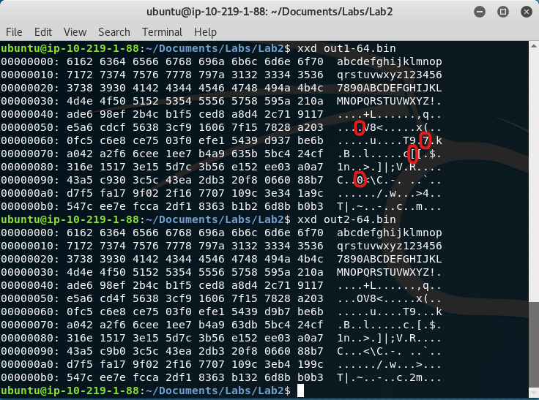

## Task 1.2

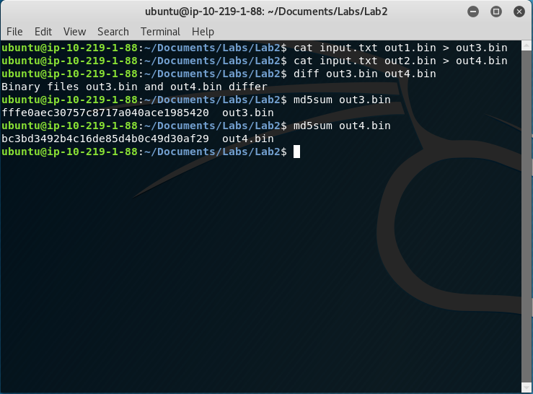

## Task 1.3